

Year 9 Science
Biology 1 Test: Systems

SECTION 1: MULTIPLE CHOICE (1 mark each)
Circle your answer on the multiple choice answer sheet.

- The part of the brain associated with thought and reasoning is the
  - Cerebellum
  - Medulla
  - Cerebrum
  - Hypothalamus

- What two parts make up the central nervous system?
  - Brain-Heart
  - Head-Spine
  - Brain-Spine
  - Cranium-Spine

- What neurons carry messages from the central nervous system to effectors?
- Sensory neurons
- Connector neurons
- Motor neurons
- None of the above

- Neurons are covered with an insulating layer called?
- Dendrites
- Muscle sheath
- Cell body
- Myelin sheath

- The cerebellum part of the brain controls?
- Running-Jumping
- Coordination-Balance
- Throwing-Falling
- All of the above

- What fluid protects the brain and the spinal cord?
- Cranium
- Spinal
- Cerebrospinal
- Brain

- What hormone does the Thyroid gland produce?
- Thyroxin
- Adrenaline
- Triiodothyronine
- Amino Acid

- The pituitary gland is often called the?
  - Master gland
  - The boss gland
  - Hypothalamus gland
  - None of the above

- The process of maintaining a constant internal environment is known as
  - Homeostasis
  - Effector
  - Receptor
  - Hormone

10. Endothermic means that you
- Maintain constant metabolism
- Maintain constant hormone levels.
- Maintain constant body temperature
- Maintain constant level of fluids

11. Junction between two neurons is known as _______________
- Synapses
- Neurotransmitter
- Dendrite
- Axon terminal

12. How do neurons communicate (chemically) with each other___________
  - Synapses
  - Neurotransmitter
  - Dendrite
  - None of the above

13. State the general name for organisms that cause disease.
  - Bacterium
  - Antibody
  - Pathogen
  - Virus

14. Pathogenic bacteria can cause diseases such as ___________________
  - Whooping cough
  - Diphtheria
  - Meningococcal
  - All of the above

15 What is a virus ___________
  - Pathogen
  - Bacteria
  - Pathogen microorganisms
  - A host cell

SECTION 2: WRITTEN
Write your answers in the spaces on the answer sheet provided.

- Name the parts of the endocrine system labelled on the diagram below (6)
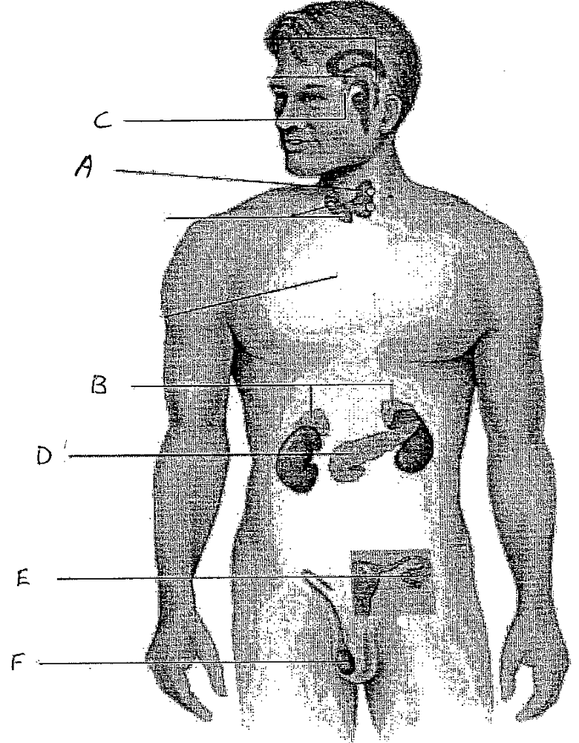

- Describe the function of A, B and D (3)

3. Explain why the pituitary gland is often referred as the “master gland” (1)

END OF TEST (OUT OF 25 MARKS)

